**R Code for Examples in the book**

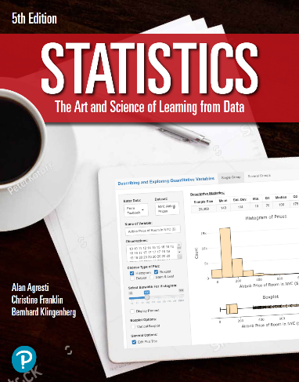

***“Statistics: The Art and Science of Learning from Data”***

**by Agresti, Franklin and Klingenberg, 5th edition**

**Chapter 13**

**Example 8: House Selling Price – Histogram of Standardized Residuals**

## Reading in data

houses <- read.csv(file='https://raw.githubusercontent.com/artofstat/data/master/Chapter13/house_selling_prices_or.csv')

## Fitting in multiple regression model

linReg <- lm(HP.in.thousands ~ House.Size + Bedrooms, data = houses)  
linReg

##   
## Call:  
## lm(formula = HP.in.thousands ~ House.Size + Bedrooms, data = houses)  
##   
## Coefficients:  
## (Intercept) House.Size Bedrooms   
## 60.10214 0.06298 15.17041

## To obtain standardized residuals

mystdres <- rstandard(linReg)  
head(mystdres)

## 1 2 3 4 5 6   
## 0.2643425 0.6441210 -1.6377349 0.1023211 -0.3326797 1.9403118

## 

## To create a histogram of the standardized residuals

hist(mystdres, breaks = 20, col = 'tan', main = 'Histogram', xaxt = 'n',  
 xlab = 'Standardized Residual', ylab = 'Frequency')  
axis(1, at = seq(-5, 6, by = 1))

